SIR SYED UNIVERSITY OF ENGINEERING & TECHNOLOGY
INFORMATION TECHNOLOGY DEPARTMENT

Spring 2022

System & Network Administration (IT-308)
Lab-Quiz

Semester: V Batch: 2020s
Max Marks: 5

INSTRUCTIONS

Provide your topology diagram with your name and IP addresses labelled on it

Set unique hostname of router and switches including your name in the hostname
- Provide the screenshot of the following:
- Run “show running-configuration” on Router 0 and Router 1
- Submit your assignment in word or pdf format with your name and roll n.o mentioned
- Assignment should be submitted on email to tehmeed@ssuet.edu.pk

TOPOLOGY:

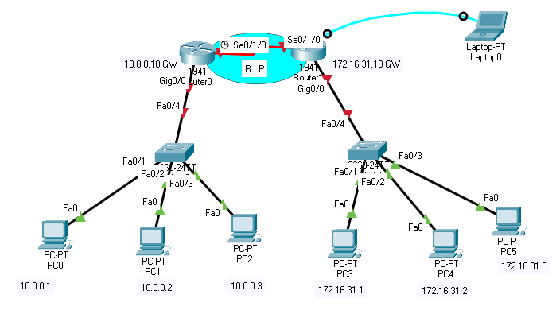

1) Design the following topology and assign the IP addresses according to the topology. Assign your own suitable IPs for pt-pt WAN link (1pts)

2) Use RIP as the routing protocol to create connectivity between the network devices. Ping
PC 4 from PC1, type “ show ip route” on Router 1 and attach both the screenshots. (1pts)

3) Console into Router 1 from the Terminal on Laptop 0, configure the hostname as router-(your name), Configure IP addressing on Router 1, Configure SSH on Router 1 and save the configuration to NVRAM. (1 pts)

4) SSH into Router 1 from PC 2 and attach the screenshot of the command prompt. (1 pts)

5) What is the difference between enable password and enable secret? What is the port n.o of
SSH (1 pts)

